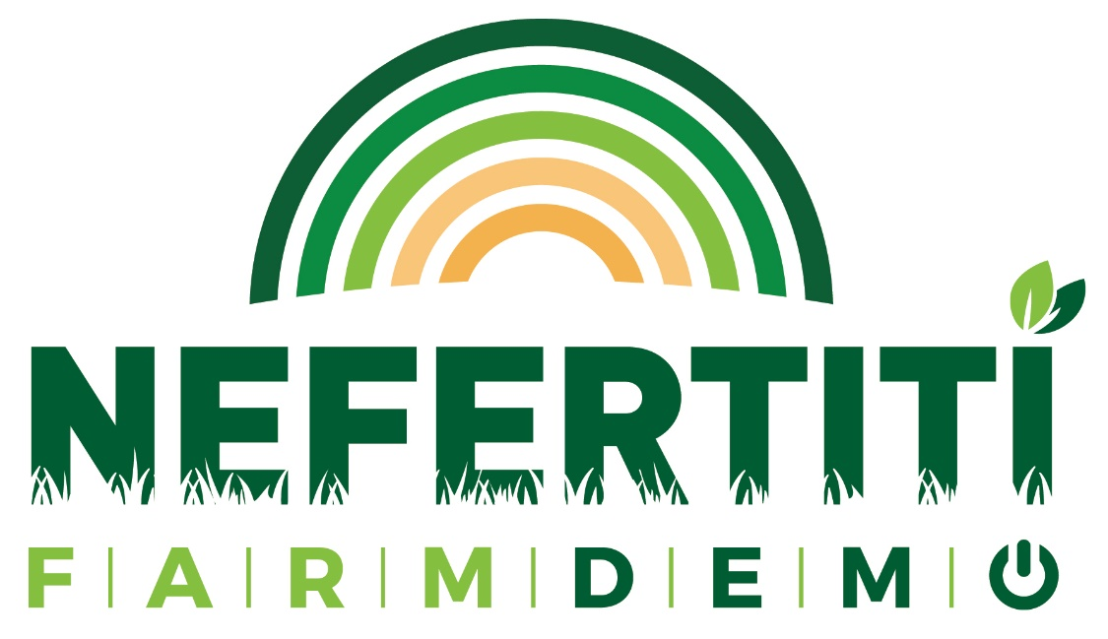

Membership in the NEFERTITI Network

Dear Sir or Madam,
Since January 2018, ACTA together with thirty-one European partners, launched the project NEFERTITI, funded through the Horizon 2020 Programme of the European Commission (Grant Agreement number 772705).
NEFERTITI is a unique project that establishes 10 thematic networks that bring together regional clusters (hubs) of Demo-activities and the involved actors. NEFERTITI focuses on creating added value from the exchange of knowledge, actors, farmers and technical content over the networks in order to boost innovation, to improve peer to peer learning and improve network connectivity between farms actors over Europe. A monitoring and learning program supports the systematic extraction of lessons learnt, lessons to be shared with wide audiences including AKIS actors and public authorities. A web based platform unlocks the experience, actors, demonstration details and the related content for wide spread sharing, enhanced by dedicated production of relevant material in each language of the partners.
NEFERTITI requires the active involvement of external stakeholders in order to achieve its goals, meaning:

- Developing ‘Dynamic Action Plans’ at the level of the network, by identifying the needs of demonstration actors, in terms of knowledge and ‘know-how’ for networks’ activities, taking into account the diversity of EU AKIS
- Establishing and sustaining interactive thematic networks at regional, national and EU levels by sectors and themes to boost knowledge exchanges and cross fertilisation
- Supporting annual cycles of demo-activities and peer-to-peer learning in the regional hubs that will be established involving all relevant AKIS actors. This objective aims to underpin ‘learn by doing’ on how to improve uptake of knowledge among farmers and improve science-practice interactions

- Fostering the learning process of all actors involved in demo-activities throughout the networks to identify best practices for demonstrations and interactivity between demonstrations on similar themes over Europe
- Improving the policy dialogue and networking the regional European Structural Investment Funds (ESIF) managing authorities to ensure the network sustainability
- Establishing a web-based platform including knowledge reservoirs related to demo-activities including ready-to-use knowledge from other national, EU and EIP related projects organised by themes and sectors
- Promoting effective use of demo- and network activities by communicating and disseminating the practical-oriented outcomes adapted at local level

NEFERTITI will consider two kinds of Membership to achieve its goal:
- Participant region: participant regions are interested in pilot- and demofarms. They will be informed and involved in activities of the project in their own country/region or a region close by. They can be involved through participation to workshops, roundtables, field visits and demonstration events, questionnaires, surveys, etc. Participation is free-of-charge and on a voluntary basis. Participant regions will be linked-up together and regularly informed about the project events, results and outcomes.

- Observer region: observer regions are followers and supporters of the project. They are regularly informed about the project events, activities and outcomes.
Being active or passive, the membership to the NEFERTITI Network is completely free-of-charge and on a voluntary basis. The involvement of the members will only depend on their willingness to support the NEFERTITI network without obligation to participate actively in the project activities. Members can change the form of their membership only one time during the timeframe or exit at any time without penalty.

Why to engage in NEFERTITI:
- Share the research results and practical applications produced in your region /country with the NEFERTITI community
- Become an active partner of the NEFERTITI community in Europe for building up a sustainable future with other regions/countries.
- Learn from research results, best practices and innovations in order to improve the sustainability of your arable, horticulture, and/or livestock systems
- Learn about farmer’s needs and challenges as well as best-practices and solutions in your region/country.
- Share your ideas and vision on sustainable agriculture
- Benefit from innovation partnerships across new value chains, integrating complementary knowledge to valorize sustainable agri sources
- Get access to other/new agri players in the hubs and the participating EU regions
- Set up your own business model to safe and/or make money with sustainable agri sources

Interested in being part of the game? Then please fill in the following Membership Form to let us know how you would like to get involved!

With Best regards

Adrien Guichaoua- NEFERTITI project Coordinator
And the whole NEFERTITI Team

Membership Form

By signing below, I confirm that I agree to participate in the NEFERTITI Network as member and provide necessary feedback according to the type of Membership selected. I confirm also that I have read and understood the information package and gave my consent for the use of my personal data by signing the informed consent.

Membership:
1. | Participant region: participant regions are interested in pilot- and demofarms. They will be informed and involved in activities of the project in their own country/region or a region close by. They can be involved through participation to workshops, roundtables, events, questionnaires, surveys, etc. Participation is free-of-charge and on a voluntary basis. Participant regions will be regularly informed about the project results and outcomes.
2. | Observer region: observer regions are followers and supporters of the project. They are regularly informed about the project activities and outcomes.

Personal Information:
Gender:
Title:
Name:
Surname:
Organisation:
Adress (only active members):

Position:
Email:
Domain of expertise (only active members):
I agree that my logo and name appears on the NEFERTITI website as active member: yes / no

________________________ ___________________________ ________________
Name of Member Signature Date

Information sheet

Title
Membership to the NEFERTITI networkactivities and studies
Purpose
The European Union is funding the NEFERTITI project through the Horizon 2020 Programme as of January 2018 (Grant Agreement number 772705).
NEFERTITI is designed to develop thematic networks that will connect actors of the arable/horticulture/livestock value chain and will enable and support farmers and regional authorities to exploit innovations and best-practices through the transfer of know-how and information. Projects´ actions will contribute to an economically viable and sustainable development in rural areas towards the enhancement of an EU Agriculture.
The aim of this membership is to gain a better understanding of the agriculture ecosystem through your active involvement in the project activities.
You have been invited to participate because you are a member of the ERIAFF network.
Voluntary Participation / Withdrawal Option
Your participation is voluntary. You may choose not to participate. If you decide to participate, you may withdraw at any time. You are able to decline to answer any particular question you do not wish to answer for any reason. Additionally, you may refuse and exit at any time without penalty.
Timeframe
The membership is only asked for the timeframe of the project, meaning until end of December 2021. The future membership will depend on the continuation of the network activities after this. An update of the membership will be asked according to the organisation that will undertake the future network. You will be contacted in due time.
Procedure and Requirements (Use of Information, Confidentiality, Process)
Your data privacy and the data from your network will be entirely secured, all answers will be treated in respect to confidentiality rules of the European Commission. (For more information please click here: http://ec.europa.eu/justice/newsroom/data-protection/infografic/2017/index_en.htm)
Your data will be stored in a secured server with a password protected access with access only to the NEFERTITI project partners. The information you provide for the membership – particularly personal data, if you chose to provide it – will be treated as confidential and will be used for the strict purpose of contacting you for information about the project or to ask your feedback on project activities. The contact details you provide will not be transferred to externals nor used for marketing or advertisement.
No one, apart from the organisations in charge of collecting and assessing the data, will be able to identify you and no one will know whether or not you participate in the network. Your membership will only be disclosed if you agree to do so by allowing us to use your logo and organisation’s name on our website. In no case persons names will be disclosed.
Your provided data will be stored until the 31.12.2022 on a single database managed by Lieve Prins, officer at the Province of South-Holland located in Zuid-Hollandplein 1, 2596 AW Den Haag, Netherlands. After the 31.12.2021 (storage period) the data will be automatically erased. In the case the network is sustainably transferred to another organisation after the project completion you will be asked upon your agreement for the transfer of your data to the undertaking organisation.
You may request within the storage period at any time to have your personal contact details erased. In this case, please contact the below mentioned responsible in charge.
There are no known risks or discomforts associated with this membership.
Contact
For more information about the membership, contact Lieve Prins, officer at the Province of South-Holland located in Zuid-Hollandplein 1, 2596 AW Den Haag, Netherlands, at l.prins@pzh.nl.
If you feel you have not been treated according to the descriptions in this form, or you have any questions, concerns, or complaints that you which to address to someone other than the responsible for executing, you may contact the project coordinator: Adrien Guichaoua (adrien.guichaoua@acta.asso.fr).
Consent
By signing the Informed Consent Form annexed to this document, you are indicating that you have read the consent form, you are age 18 or older and that you voluntarily agree to participate under the terms and conditions set.

Informed Consent Form

By signing below, I confirm that I have read and understood the information package and in particular have noted that (please tick box as appropriate):

1. | I have read and understood the information about the project and what my participation will involve, as provided in the NEFERTITI Membership information form.
2. | I have been given the opportunity to ask questions about the project and my participation.
3. | I voluntarily agree to participate in the project.
4. | I understand I can withdraw at any time without giving reasons and that I will not be penalised for withdrawing nor will I be questioned on why I have withdrawn.
5. | If I decide to withdraw from the study, I agree that the information collected about me up to the point when I withdraw may continue to be processed.
6. | The procedures regarding confidentiality have been clearly explained (e.g. use of names, pseudonyms, anonymisation of data, etc.) to me.
7. | The use of the data in research, publications, sharing and archiving has been explained to me and I agree with this
8. | I understand and agree that other researchers will have access to this data only if they agree to preserve the confidentiality of the data and if they agree to the terms I have specified in this form.
9. | I understand that if I have any additional questions or if I have any concerns about the ethical conduct of the project I can contact the research team;
10. | I understand my responsibilities as a member of the network.
11 | I agree to be interviewed or audio/video recorded during the workshop/rountables and allow the use of these for communication purpose.
12. | I agree to be contacted for participation in future research

Member:

________________________ ___________________________ ________________
Name Signature Date

